Visitor Pattern
# Source: AI Source: Provided by: [Data Path: Persons Table -> ID Column: 1, Name_En Column: Motasem Essam] -> From: [ChatGPT] on [1/23/2026]
The Visitor Pattern allows you to add new operations to existing object structures without modifying those structures.
👉 Think of it like a tax auditor visiting different departments: each department stays the same, but the auditor performs different operations on them.

🔑 Key Points
# Source: AI Source: Provided by: [Data Path: Persons Table -> ID Column: 1, Name_En Column: Motasem Essam] -> From: [ChatGPT] on [1/23/2026]
• Separates algorithm from object structure
• Uses double dispatch (object + visitor)
• Makes it easy to add new operations
• Works well with complex object structures

❌ Bad Example
# Source: AI Source: Provided by: [Data Path: Persons Table -> ID Column: 1, Name_En Column: Motasem Essam] -> From: [ChatGPT] on [1/23/2026]
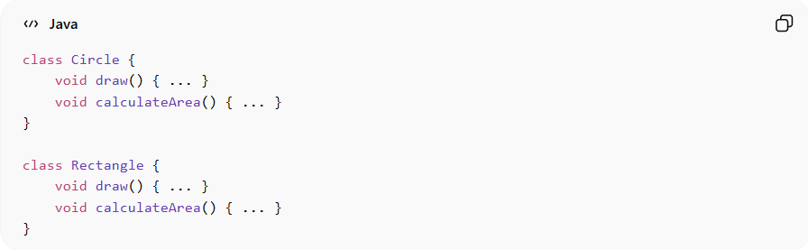
class Circle {
void draw() { ... }
void calculateArea() { ... }
}

class Rectangle {
void draw() { ... }
void calculateArea() { ... }
}
Problems:
• Adding a new operation (e.g., export, print) requires modifying all classes
• Violates Open/Closed Principle
• Leads to code duplication

✅ Good Example
# Source: AI Source: Provided by: [Data Path: Persons Table -> ID Column: 1, Name_En Column: Motasem Essam] -> From: [ChatGPT] on [1/23/2026]
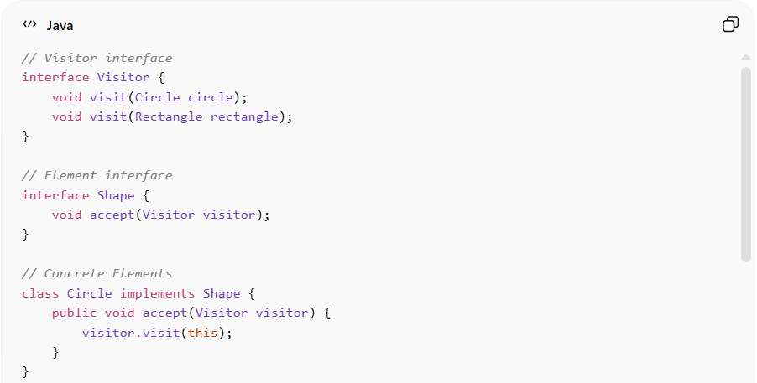

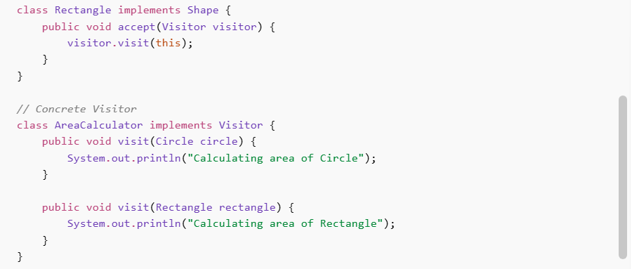
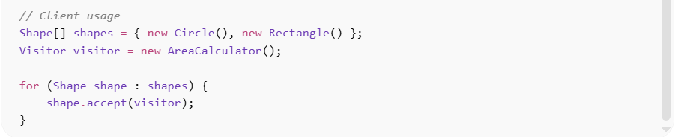
// Visitor interface
interface Visitor {
void visit(Circle circle);
void visit(Rectangle rectangle);
}

// Element interface
interface Shape {
void accept(Visitor visitor);
}

// Concrete Elements
class Circle implements Shape {
public void accept(Visitor visitor) {
visitor.visit(this);
}
}

class Rectangle implements Shape {
public void accept(Visitor visitor) {
visitor.visit(this);
}
}

// Concrete Visitor
class AreaCalculator implements Visitor {
public void visit(Circle circle) {
System.out.println("Calculating area of Circle");
}

public void visit(Rectangle rectangle) {
System.out.println("Calculating area of Rectangle");
}
}

// Client usage
Shape[] shapes = { new Circle(), new Rectangle() };
Visitor visitor = new AreaCalculator();

for (Shape shape : shapes) {
shape.accept(visitor);
}
Benefits:
• Add new operations without modifying existing classes
• Keeps business logic separate from data structures
• Improves maintainability and scalability

⚡ Advantages
# Source: AI Source: Provided by: [Data Path: Persons Table -> ID Column: 1, Name_En Column: Motasem Essam] -> From: [ChatGPT] on [1/23/2026]
• Supports Open/Closed Principle for adding operations
• Centralizes related operations in one place
• Works well with complex object hierarchies
• Enhances separation of concerns

⚠️ Disadvantages
# Source: AI Source: Provided by: [Data Path: Persons Table -> ID Column: 1, Name_En Column: Motasem Essam] -> From: [ChatGPT] on [1/23/2026]
• Hard to add new element types (requires updating all visitors)
• Can increase complexity
• Requires understanding of double dispatch

🛠️ Use Cases
# Source: AI Source: Provided by: [Data Path: Persons Table -> ID Column: 1, Name_En Column: Motasem Essam] -> From: [ChatGPT] on [1/23/2026]
• Compilers – syntax tree processing
• Document processing – exporting to PDF, HTML, etc.
• Graphics systems – applying operations on shapes
• Reporting systems – generating reports on data structures

